**I am writing to make a request for information under the Freedom of Information Act 2000. I would like to request the following information regarding your agency nurse spend for the months of March, April, and May 2024, specifically for "Band 2 HCAs" and separately for "all other Nursing & Midwifery roles":**

**1. Top 10 Nurse Agencies by Spend:**

**• Please provide a list of your top 10 nurse agencies by spend for the months of March, April, and May 2024.**

**N/A**

**• For each agency, specify whether they are on-framework or off-framework. N/A**

**• Provide this information separately for "Band 2 HCAs" and "all other Nursing & Midwifery roles".**

**N/A**

**2. On-Framework vs Off-Framework Spend:**

**• Provide the total spend for the months of March, April, and May 2024.**

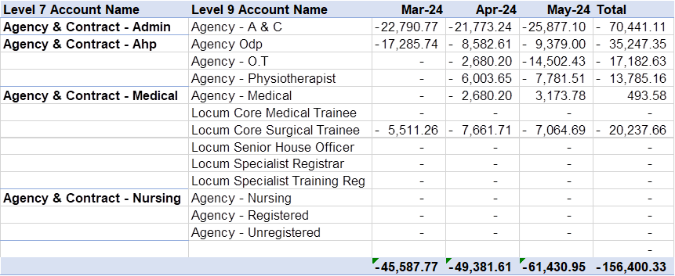

**• Break down the spend into on-framework and off-framework categories.**

**All spend On Framework**

**• Provide this information separately for "Band 2 HCAs" and "all other Nursing & Midwifery roles".**

**N/A**

**3. Compliance with NHS England Rate Caps:**

**• Specify the number of agency shifts in May 2024 that were compliant with NHS England Rate Caps.**

**We do not hold this figure.**

**• Provide this information separately for "Band 2 HCAs" and "all other Nursing & Midwifery roles".**

**N/A**

**4. Compliance with Agency Spend Ceiling:**

**• Total agencies spend (all staff groups, including Nursing & Midwifery (and HCAs), Medical and Dental, Non-Medical Non-Clinical, and any others) between 1st January and 31st May 2024.**

**• What does this figure represent as a percentage of the Trust's total pay bill for the same period.**

|  |  |  |  |  |  |
| --- | --- | --- | --- | --- | --- |
|  | **Jan-24** | **Feb-24** | **Mar-24** | **Apr-24** | **May-24** |
|  |  |  |  |  |  |
| **Percentage of total pay** | **8.35%** | **5.47%** | **4.64%** | **6.15%** | **7.70%** |